Networking Week 1

Brent Schoenmakers & Cihan Kurt

**Task 2:**

*Provide adjusted network drawing with the configured interfaces:*

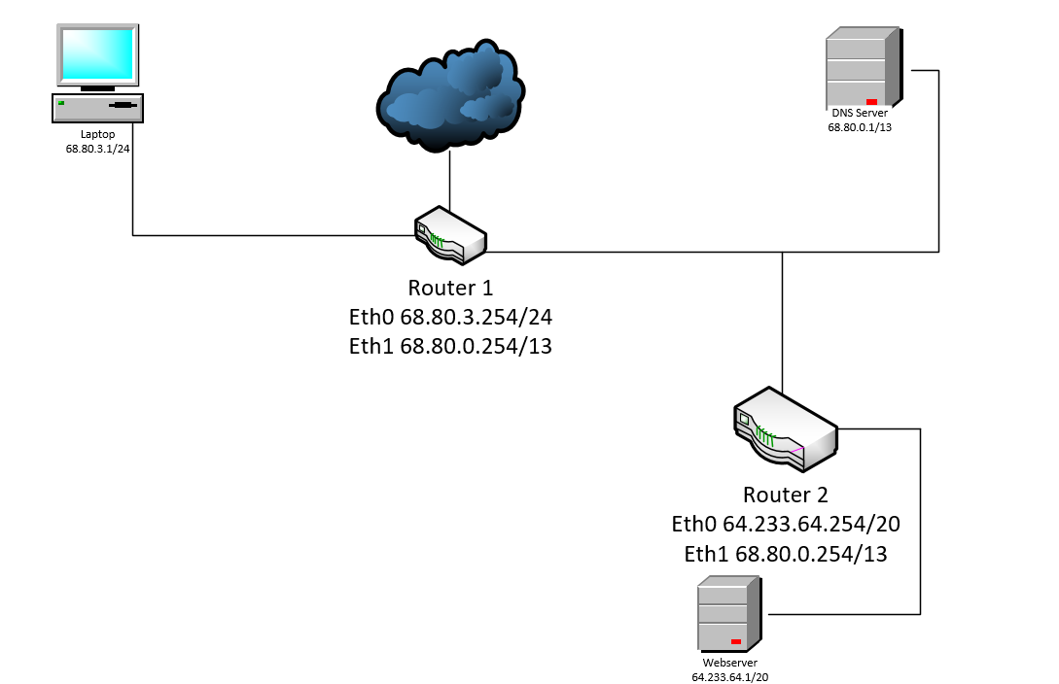

We can’t separate the text of the routers. Each icon has just one textbox. So here a little explanation about the Eth’s;

Router1: Eth0 should be on the left side of the router and Eth1 should be on the right side of the router.

Router2: Eth0 should be on the bottom of the router and Eth1 should be on the top of the router.

*For each of the 3 subnetworks provide a screenshot for a successful ping between two nodes within the same subnetwork.*

*Router 1 to laptop:*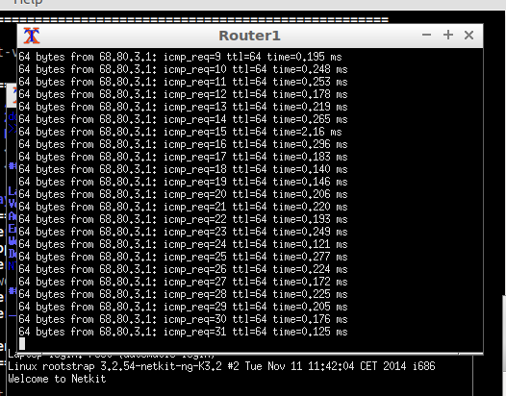

*Router 1 to DNS Server:*

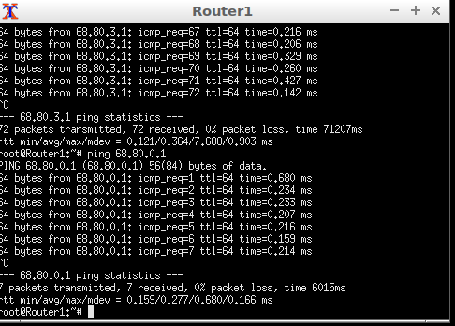

*Router 2 to Webserver:*

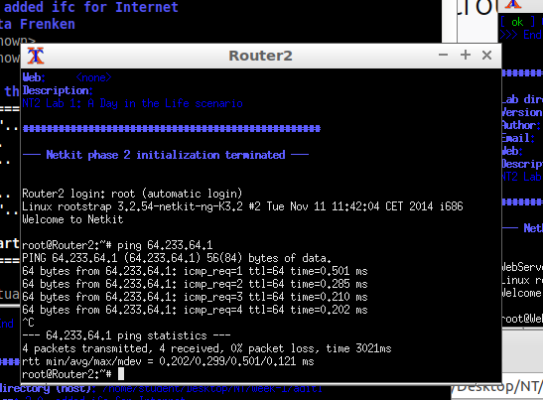

**Task 3:**

*Provide screenshots of the following successful pings.*

*Laptop to WebServer*

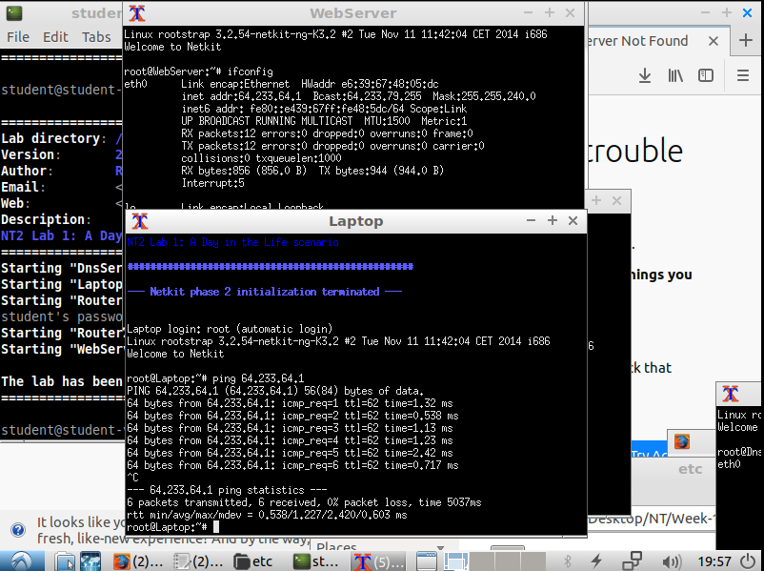

*DnsServer to Laptop*

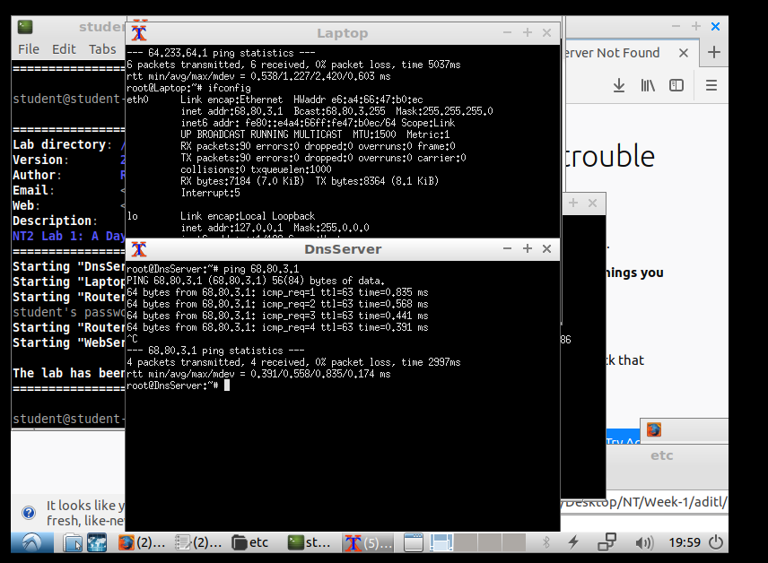

*DnsServer to WebServer*

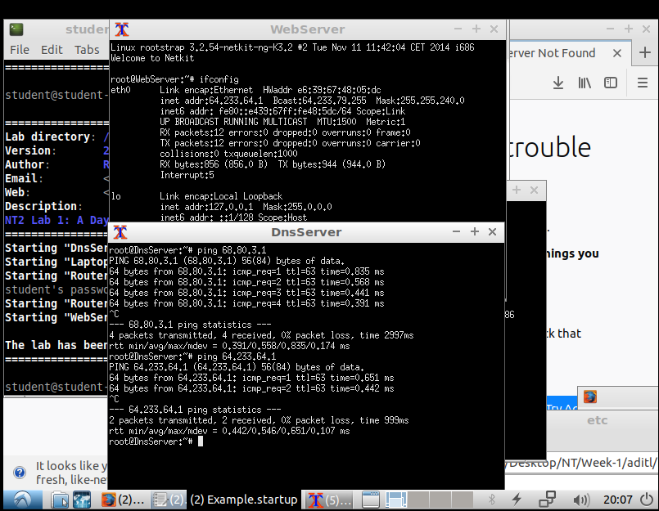

**Task 4:**

What did change after using ARP and why? Provide the screenshots of the changed ARP tables.

*Checking if ARP cache is clean;*So we did use the ARP command in the laptop node and WebServer node. Since we got no response, we assume that the ARP tables are empty.

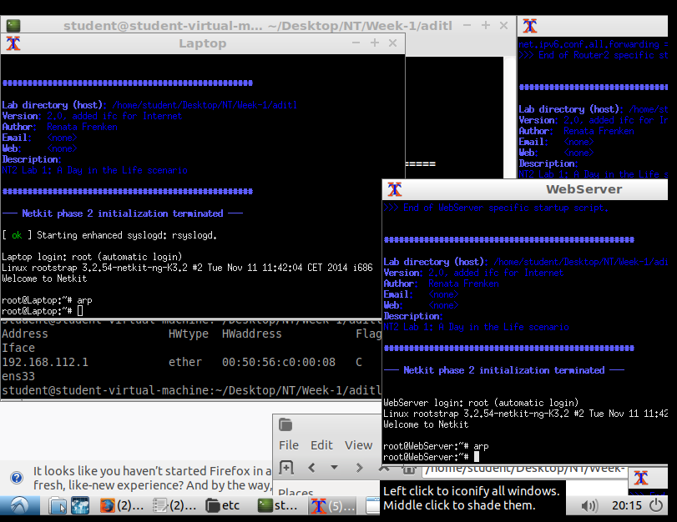

*Provide a screenshot of the ARP tables after pinging between Laptop and WebServer.*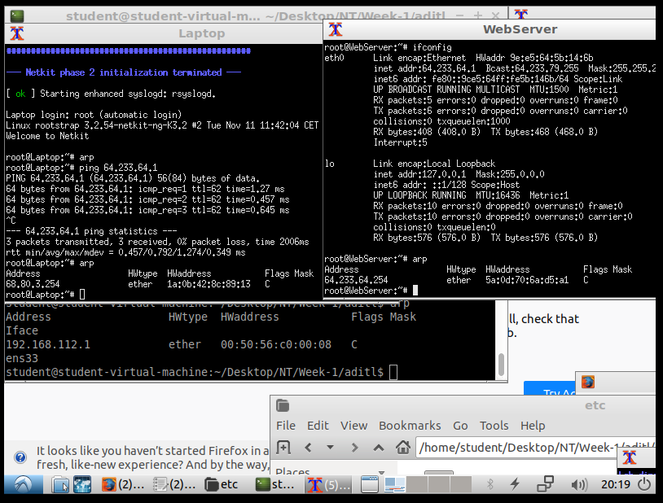  
  
We did notice that the addresses in the ARP Tables are actually the same IP addresses as given in the routes. Laptop went with a default gateway through router 1. While the WebServer has been reached by Router 2. The ARP tables of the other nodes has been changed as well.

**Task 5:**

1. *Suppose we have the IP address 122.33.196.145/24*

*Fill in the following items for this address:*

1. *Network Address:*

Since the netmask is 255.255.255.0 a calculation won’t be necessary. The network address is 122.33.196.0

1. *Broadcast Address*

The broadcast address of this network address will be: 122.33.196.255

1. *Subnet Mask*

The subnet mask is 255.255.255.0 this can also be written as /24.

1. *Suppose we have the IP address 163.248.223.229/25*

*Fill in the following items for this address:*

1. *Network Address*

Thanks to the netmask we can’t just determine the network address. We need to do some calculations.   
Our netmask is 25. 25 contains 3x8(full byte) and 1.   
This means that the netmask can also by written as 255.255.255.128

This makes our network address: 163.248.223.128

1. *First Host*

Since we can not use our network address it self as a host, the first host will be:  
163.248.223.129

1. *Last Host*

Since we can not use the broadcast address it self as a host, the last host will be:  
163.248.223.254

1. *Broadcast Address*

This one is easy, 163.248.223.255

**The routing tables:**

We changed the start up files instead of the interfaces. We know that in the future we have to change the interfaces and it would be useful if we already did this. They can be found on the next page.

Router 1

ifconfig eth0 up

ifconfig eth0 68.80.3.254 netmask 255.255.255.0

ifconfig eth1 up

ifconfig eth1 68.80.0.254 netmask 255.248.0.0

route add -net 68.80.0.0 gw 68.80.0.254 netmask 255.248.0.0

route add -net 68.80.3.0 gw 68.80.3.254 netmask 255.255.255.0

route add -net 64.233.64.0 gw 68.80.0.253 netmask 255.255.240.0

/etc/init.d/networking start

sysctl -w net.ipv6.conf.all.forwarding=1

Laptop

ifconfig eth0 up

ifconfig eth0 68.80.3.1 netmask 255.255.255.0

route add default gw 68.80.3.254

/etc/init.d/networking start

WebServer

ifconfig eth0 up

ifconfig eth0 64.233.64.1 netmask 255.255.240.0

route add default gw 64.233.64.254

/etc/init.d/networking start

DnsServer

ifconfig eth0 up

ifconfig eth0 68.80.0.1 netmask 255.248.0.0

route add -net 68.80.3.0 gw 68.80.0.254 netmask 255.255.255.0

route add -net 64.233.64.0 gw 68.80.0.253 netmask 255.255.240.0

/etc/init.d/networking start

Router 2

ifconfig eth0 up

ifconfig eth0 64.233.64.254 netmask 255.255.240.0

ifconfig eth1 up

ifconfig eth1 68.80.0.253 netmask 255.248.0.0

route add -net 64.233.64.0 gw 64.233.64.254 netmask 255.255.240.0

route add -net 68.80.0.0 gw 68.80.0.253 netmask 255.248.0.0

route add -net 68.80.3.0 gw 68.80.0.254 netmask 255.255.255.0

/etc/init.d/networking start

sysctl -w net.ipv6.conf.all.forwarding=1